MicroStrategy with RStudio offers several benefits by leveraging the powerful data science capabilities of R along with MSTR's visualizations. As a result, users can extract deeper insights from their data, make more informed decisions, and uncover valuable opportunities for the organization.

Following installations and pre-requisites apart from MicroStrategy are needed for Integration of MSTR with RStudio:

**Installations**:

1. R 3.6.0+
2. RStudio Desktop 1.2.1335+
3. MSTRIO Package in RStudio.

**Pre-requisites**:

1. CORS enabled on MicroStrategy Library server
2. Cookies sent by MicroStrategy Library server have SameSite parameter set to None.

**Installations :**

The detailed steps for installation are given below

1. R Installation

Download R setup from the link and install the setup

<https://cran.r-project.org/bin/windows/base/>

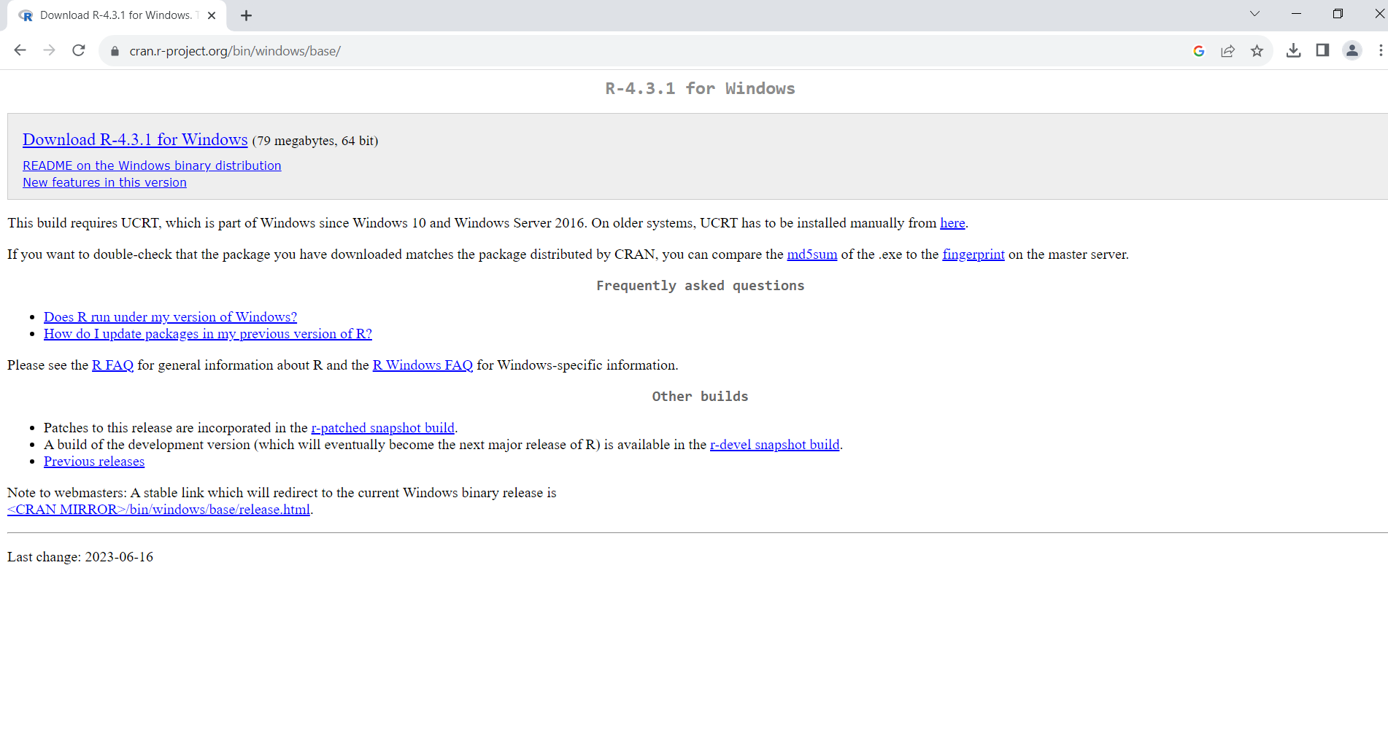

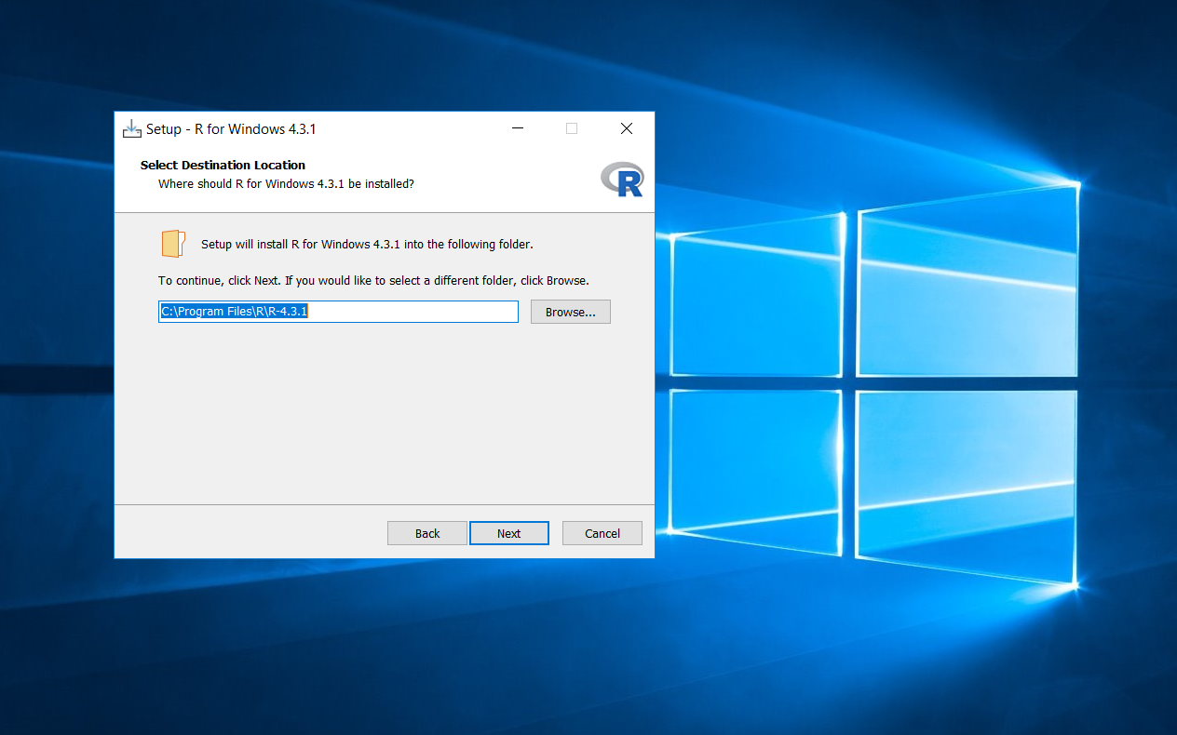

1. Installing RStudio

Download RStudio (Open Source Version) from the link and install the setup

<https://posit.co/download/rstudio-desktop/>

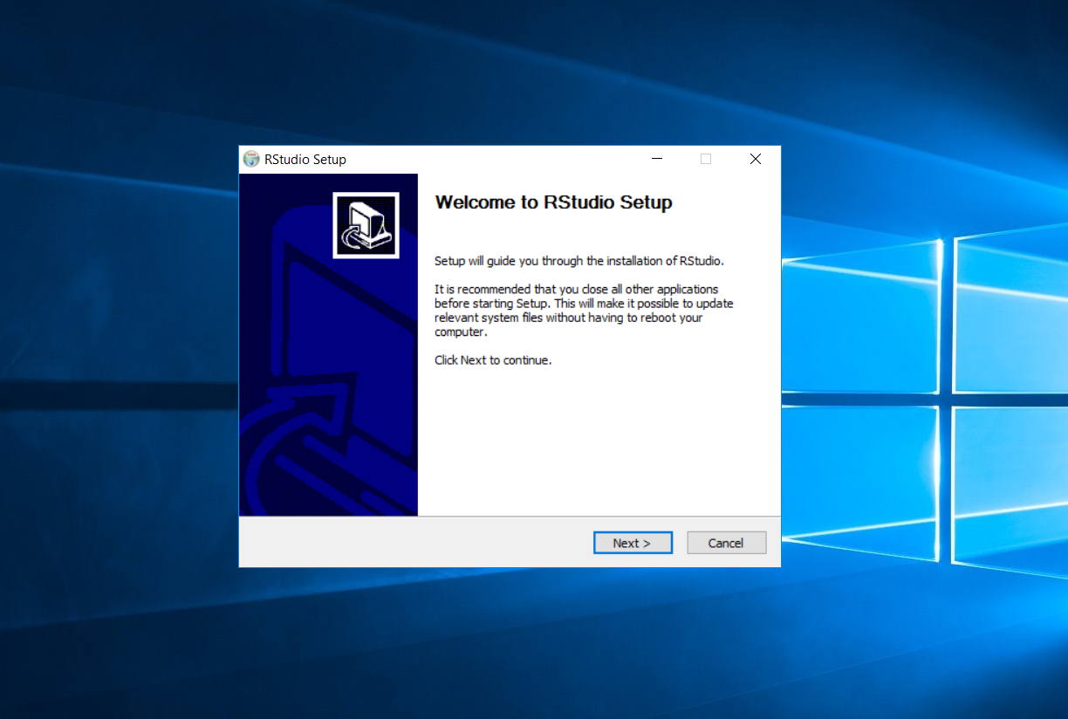

1. Installing MSTRIO

MSTRIO can be installed by heading to tools menu and clicking on install packages or by entering this command in console –

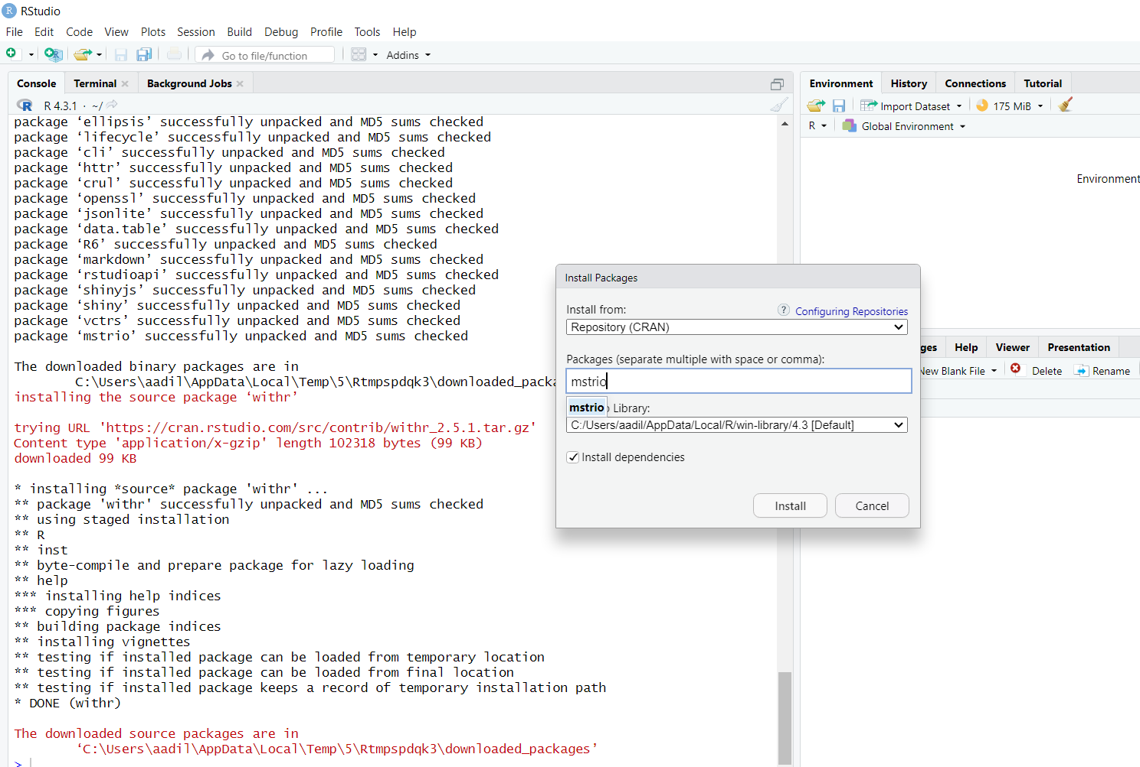

**Pre-requisites**:

1. CORS enabled on MicroStrategy Library server

You need to login to library admin to change the settings for CORS (Cross-Origin Resource Sharing). If you don’t know password for library admin , it can be found in the following path-

C:\Program Files (x86)\Common Files\MicroStrategy\Tomcat\apache-tomcat-9.0.22\conf

Once you login to library Admin, head in to library server and change the security settings from none to ‘specific’ or ‘All’ according to the requirement

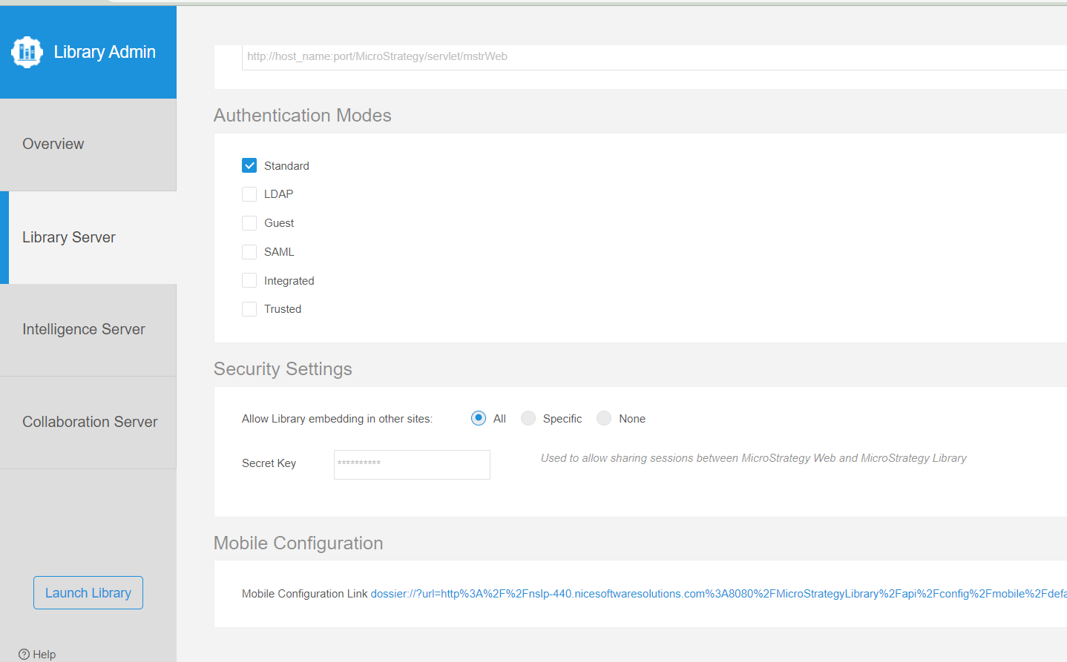

1. Cookies sent by MicroStrategy Library server have SameSite parameter set to None.

Changing cookies depends on the version of MicroStrategy . For MicroStrategy 2021 Update 6 or after , you can see the setting in environment settings in library environment . Set the SameSite Attribute to None.

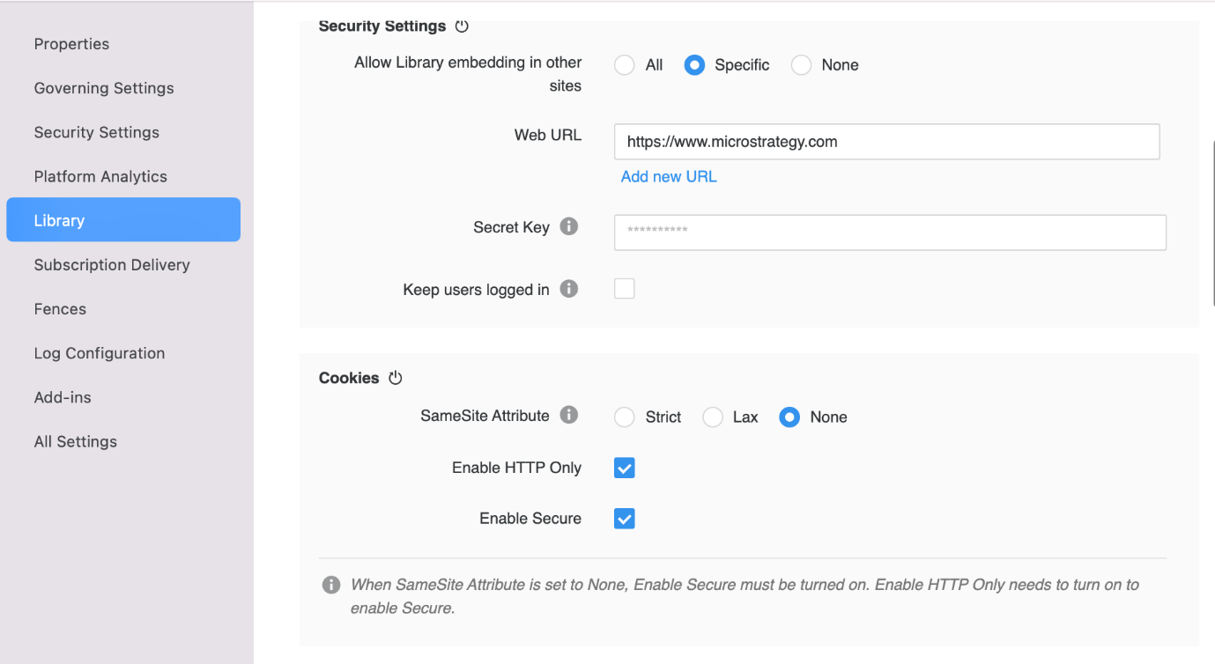

### For MicroStrategy 2021 Update 5 or before[​](https://microstrategy.github.io/embedding-sdk-docs/config/#for-microstrategy-2021-update-5-or-before)

If you are using MicroStrategy 2021 Update 5 or before, make the following changes on your server instance.

1. If context.xml doesn't already exist in the following folder location, create it: [Tomcat Folder]\webapps\MicroStrategyLibrary\META-INF\context.xml. Add the following to context.xml:

<Context>  
 <CookieProcessor sameSiteCookies="None"/>  
</Context>

1. In [Tomcat Folder]\webapps\MicroStrategyLibrary\WEB-INF\web.xml, change sameSite param-value blow to NONE to permit embedding.

*<!-- ... -->*  
<filter>  
<filter-name>cookieProcessorFilter</filter-name>  
<filter-class>com.microstrategy.web.filter.CookieProcessorFilter</filter-class>  
<init-param>  
<param-name>sameSite</param-name>  
<param-value>NONE</param-value>  
</init-param>  
</filter>  
*<!-- ... -->*

1. Ensure your Tomcat is configured to support HTTPS.
2. Restart Tomcat.